**WOMEN TECHSTERS FELLOWSHIP 2024**

**CAPSTONE PROJECT GROUP 60 (T-CYCLE TEAM)**

**PROBLEM STATEMENT DOCUMENT FOR TECH CYCLE**

1. **BACKGROUND STUDY**

In the dynamic world of technology, the rate at which tech professionals change their gadgets, particularly laptops, has accelerated significantly. This phenomenon reflects a complex interplay of technological advancements, workplace expectations, lifestyle preferences, and economic factors. The relentless pace of technological innovation drives the need for frequent upgrades, as tech professionals rely heavily on laptops for resource-intensive tasks.

To some professionals in the tech industry, laptops are no longer mere workhorses; they are personal devices. Such professionals consider aesthetics, portability, and build quality when choosing a laptop, and often upgrade to reflect their evolving tastes and lifestyle.  As technology continues to evolve, professionals will remain at the forefront of this perpetual upgrade cycle, seeking devices that empower them to excel in their work and align with their personal preferences.

On the other hand, this upgrade cycle directly affects electronic waste as it causes an increase in e-waste. Electronic waste is the fastest-growing waste stream globally, with an estimated **50 million tons** produced annually. Yet, discarded gadgets contain valuable metals and minerals worth approximately **$62.5 billion** each year. [Unfortunately, only about one-fifth of the world’s e-waste is recycled1](https://gridfiti.com/aesthetic-study-websites/).

On the other hand, during covid, the digital inclusion gaps for students were covered. However, it’s undeniable that there are still students who don’t have access to computer devices, and not all students are equally proficient with digital media. [Students without internet or computing devices face serious disadvantages in their education2](https://us.boell.org/en/2021/03/31/no-access-no-class-challenges-digital-inclusion-students), and socio-demographic factors, such as parental income, education, race, ethnicity, and immigration status, significantly influence their digital skills. Students who solely rely on mobile devices also has limited abilities to complete complex tasks, and sharing devices with family members further restricts their study time.

Old gadgets, while no longer cutting-edge for some professionals, if donated can serve as accessible and affordable tools for such students. Not every student can afford the latest laptops or tablets and older devices, donated by professionals and well-wishers bridge this gap. For students from low-income backgrounds, these gadgets provide a lifeline to digital learning. They allow access to online resources, e-books, and educational apps, leveling the playing field and ensuring that no one is left behind.

E-waste is a global concern, and responsible disposal is essential. When donated to students, they are empowered learn, collaborate, and thrive in an increasingly digital world.

1. **PROBLEM STATEMENT**

"In today's digital age, access to technology is crucial for personal and professional   
development. However, a significant barrier exists for individuals in the tech   
community who cannot afford laptops, hindering their career opportunities. Also,   
the lack of accessible and affordable solutions for responsible e-waste disposal   
hinders individuals and organizations from properly discarding their used electronic   
devices."

1. **PURPOSE**

To address these challenges, T-cycle is creating a platform designed to address the   
issue of electronic waste by creating an efficient and secure hub for individuals to   
donate and receive used gadgets. Our platform aims at giving gadgets a second life   
and making a positive impact on both individuals and the environment.

1. **SCOPE**

The in-scope features focus on establishing the core functionalities of the T-Cycle platform to facilitate secure and efficient device donation and receiving.  This ensures a strong foundation for the initial launch and allows for user feedback before expanding functionalities.

**Out-of-scope features** involve additional complexities or require partnerships that can be explored in later stages.  Focusing on core functionalities first allows the team to validate the platform's concept, gather user feedback, and make informed decisions about future development.

1. **SIGNIFICANCE**

Field: Sustainable e-waste management and digital inclusion

**5.1 IMPORTANCE**

* **Addressing the E-Waste Crisis:** Electronic waste (e-waste) is a global environmental challenge. As technology evolves, gadgets become obsolete at an alarming rate. However, improper disposal leads to environmental pollution, health risks, and resource wastage. This project steps in to address this crisis by creating a circular economy for electronics.
* **Extending Gadgets’ Lifecycles:** Project mission is to extend the lifecycles of old gadgets. Instead of discarding them prematurely, the platform encourages individuals and organizations to donate their used devices. By refurbishing and repurposing these gadgets, we ensure that they continue to serve a purpose. This not only reduces e-waste but also maximizes the value of existing resources.
* **Bridging the Digital Divide:** Access to technology is no longer a luxury; it’s a necessity. Yet, many students, aspiring tech professionals, and underserved communities lack the means to acquire essential gadgets. This project will bridge this digital divide by providing donated laptops, to those who need them most. By empowering students and learners, the platform contributes to a more equitable and inclusive society.

## **CONTRIBUTION TO THE FIELD**

## **Sustainable E-Waste Management Practices:** It sets a precedent for responsible e-waste management. By promoting reuse over disposal, it aligns with global efforts to minimize environmental impact.

## **Data-Driven Insights:** As the platform collects data on gadget donations, refurbishment processes, and impact metrics, it contributes valuable insights to the field. Researchers, policymakers, and environmentalists can analyze this data to inform better waste management policies, track e-waste trends, and advocate for sustainable practices.

## **Empowering the Next Generation:** It’s impact extends beyond gadgets. By providing students with tools for learning, it empowers the next generation of tech professionals. These students will shape the future of technology, innovation, and sustainability. It’s contribution lies not only in reducing waste but also in nurturing talent and potential.

1. **RESEARCH METHODOLOGY**

**Objectives:**

Develop a comprehensive platform designed to address the issue of electronic   
waste by creating an efficient and secure hub for individuals to donate and receive   
used gadgets.

**Research Objectives**

* **Assessing Donor Behavior and Motivations**
* **Measuring Recipient Interest**
* **Ethical Considerations and Data Privacy**
* **Analyzing Socio-Demographic Factors**

**Study area: Nigeria**

**General research methods**

● Primary [Qualitative and Quantitative]- survey forms

● Secondary [Qualitative and Quantitative]-

1. **DATA**

**Sources of data**

Literature reviews, excerpts from other researchers.

**Research method for target audience**

● Primary [Qualitative and Quantitative]

**Source of data**: Survey form

**Data collection method**: Google survey forms

**Analytical Technique**: Descriptive analysis

* 1. **RESULTS AND INFERENCE**

Here is a link to the data analytics from the survey: Results from Tech Cycle Survey

● Number of questions asked: 19

● Total response at the time of data analysis: 92

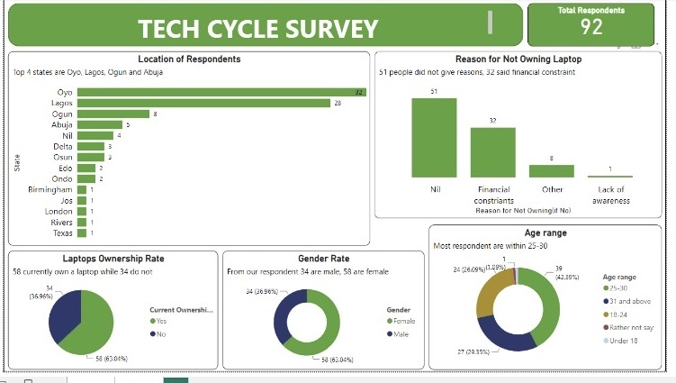

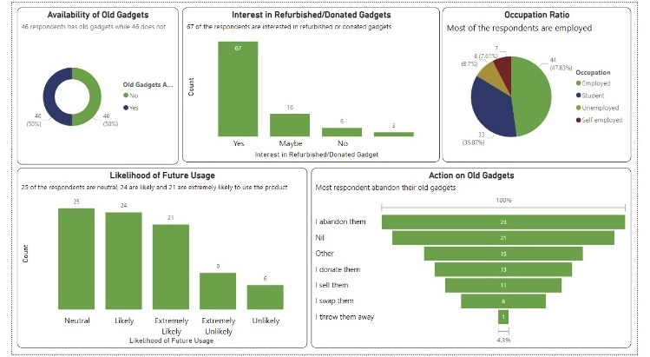

**With respect to the information gathered so far our, here’s our deliverables**

1. **DELIVERABLES**

Please find attached the links to our Deliverables.

[Product Requirement Document](https://docs.google.com/document/d/1xnavUju7QApHSIEH6hl_V1iewivmfOWrFepBjDMNC6k/edit?usp=drivesdk)

[Business Model Canvas](https://miro.com/app/board/uXjVKe25iNI=/?share_link_id=993134445650)

[User Flow](https://www.figma.com/file/cWzDrH1t3NUi0ekMEv6fQ9/Untitled?type=whiteboard&node-id=0%3A1&t=EenRthnGJmLnXVvl-1)

[User Persona,](https://www.canva.com/design/DAF_8ymH_Bc/GD9MkFyiv-D-mKq5VVv3YQ/edit?utm_content=DAF_8ymH_Bc&utm_campaign=designshare&utm_medium=link2&utm_source=sharebutton)

[Site Map,](https://www.figma.com/file/fCSITARIHQe1fJ7ssGBLsp/TECH-DRIVE-SITE-MAP?type=whiteboard&node-id=0%3A1&t=gD2no2CBmu4M4qkn-1)

[Tech Cycle Web Page Design (landing page)](https://www.figma.com/file/urxRKT0pW4F39qVpXh0EsW/Landing-page-for-Tech-Cycle?type=design&node-id=1%3A2&mode=design&t=xM44xuriHQDsIfFI-1)